

FPT STUDENT BLOG

Software Requirements Specification

**Prepared by Group 1 - SE1504**

**Nguyễn Thiện Quang**

**Nguyễn Dương**

**Lê Anh Khoa**

**Bùi Thị Thùy Linh**

**Trần Trọng Nhân**

– Ho Chi Minh, November 2021 –

Table of Contents

I. Overview **3**

1. Introduction 3

2. System Functions 5

a. Screen Flow 5

b. Screen Details 5

c. User Authorization 6

d. Non-Screen Functions 7

II. Functional Requirements **7**

1. Administrator management 7

a. List Users 7

b.List Mentors 8

c.List Categories 8

d.List Tags 9

e.List Ranks 9

f.Create New Mentor 10

2. Mentor Management 10

a. List Waiting Post 10

b. List Approved Post 11

c. List Denied Post 11

d.Create New Notification 12

e. List Notification 13

3. Student. 13

a.View Post 13

b.Comment and vote on Post 14

c.View Notification 14

d.Create New Post 15

e.Edit Profile 15

4. Guest. 16

a.Create New Account 16

b.View Post 17

# I. Overview

## 1. Introduction

FPT blog is a website where students can exchange their knowledge and understanding with others as well as learn more knowledge from others through blog posts with different topics. The website will be released on an official domain name, connecting with people everywhere through the internet, a place to share and learn more knowledge from many areas of life.

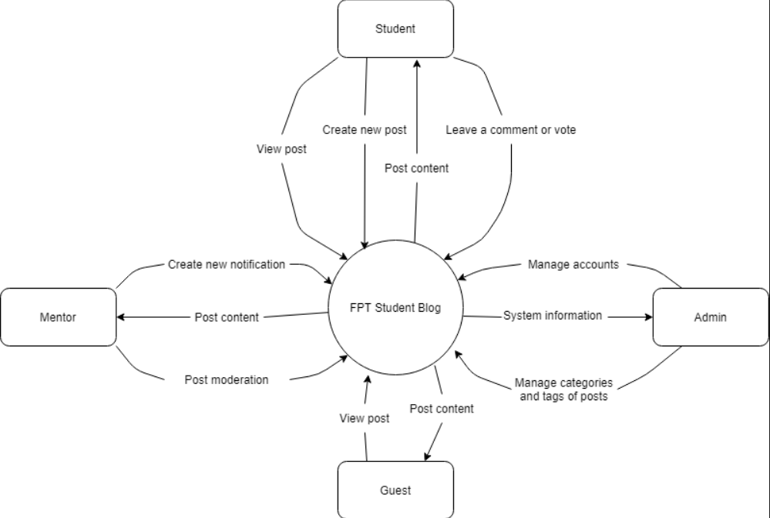

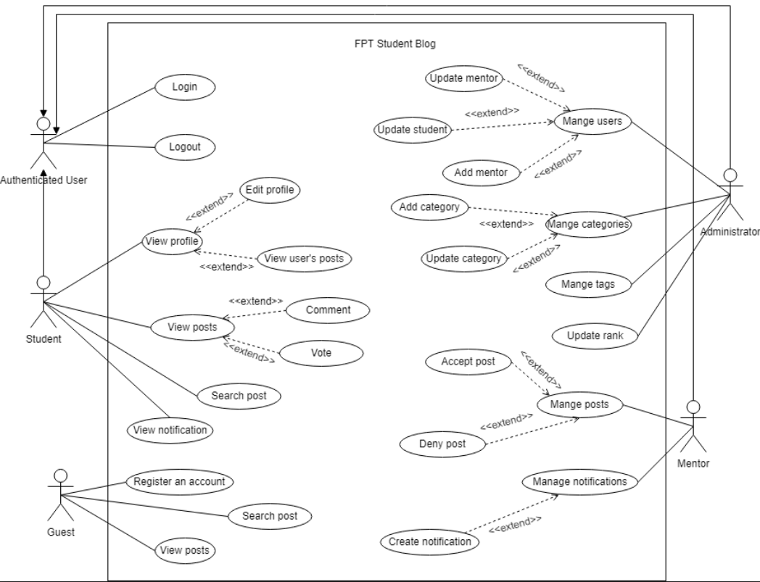

## 2. System Functions

#### a. Screen Flow

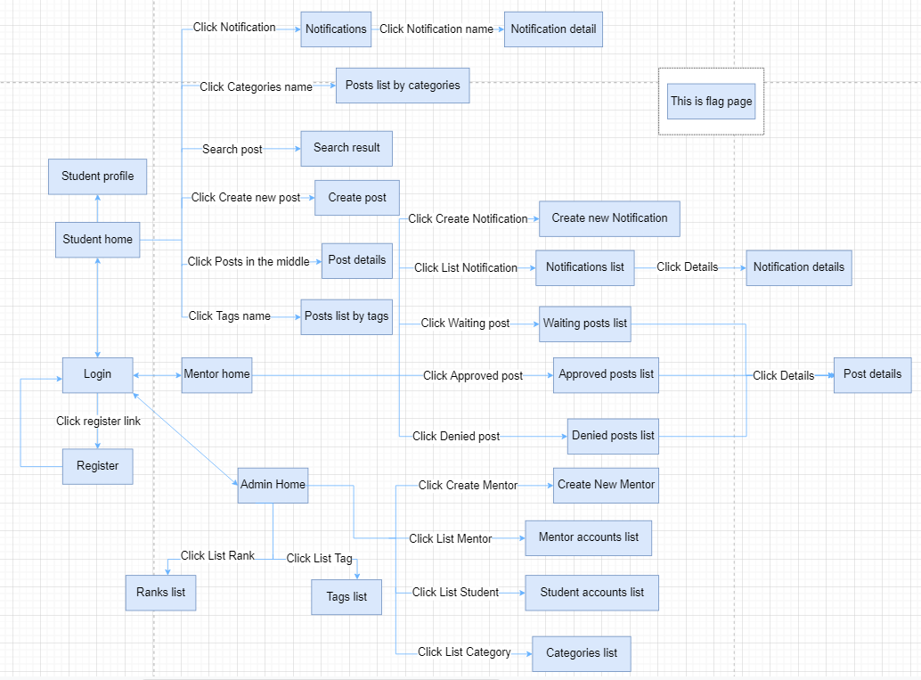

#### b. Screen Details

| # | Feature | Screen | Description |
| --- | --- | --- | --- |
| 1 | Create Post | Create Post | Students can create a new post on this page |
| 2 | Search Post | Search Result | List all searched posts by name |
| 3 | Search Post | Posts list by categories | List all posts by categories |
| 4 | Search Post | Posts list by tags | List all posts by tags |
| 5 | Show post details | Post details | Show all info of the post and students can vote, comment |
| 6 | Show notifications | Notifications | List all notifications in the system |
| 7 | Show notification details | Notification detail | Show all info of the notification and students can vote, comment |
| 8 | Create Notification | Create new Notification | Mentors can create a new notification on this page |
| 9 | Show Posts | Waiting posts list | List all waiting posts |
| 10 | Show Posts | Approved posts list | List all approved posts |
| 11 | Show Posts | Denied posts list | List all denied posts |
| 12 | Show notifications list | Notifications list | List all notifications in the system |
| 13 | Show notifications details | Notifications details | Show detail info of the notifications |
| 14 | Show post details | Post details | Show all info of the post |
| 15 | Create mentor | Create new Mentor | Admin can create a new mentor account |
| 16 | Show students | Students accounts list | List all students accounts, admin can ban |
| 17 | Show mentors | Mentors accounts list | List all mentor accounts, admin can ban |
| 18 | Show categories | Categories list | List all categories, admin can add new |
| 19 | Show tags | Tags list | List all tags |
| 20 | Show ranks | Ranks list | List all ranks |
| 21 | Student profile | Student profile | Show posts of students and their information |

#### c. User Authorization

| Screen | Guest | Student | Mentor | Administrator |
| --- | --- | --- | --- | --- |
| Create Post |  | X |  |  |
| Search Result | X | X |  |  |
| Posts list by categories | X | X |  |  |
| Posts list by tags | X | X |  |  |
| Post details | X | X |  |  |
| Notifications | X | X | X |  |
| Notification detail | X | X | X |  |
| Student profile |  | X |  |  |
| Create new Notification |  |  | X |  |
| Waiting posts list |  |  | X |  |
| Approved posts list |  |  | X |  |
| Denied posts list |  |  | X |  |
| Create new Mentor |  |  |  | X |
| Students accounts list |  |  |  | X |
| Mentors accounts list |  |  |  | X |
| Categories list |  |  |  | X |
| Tags list |  |  |  | X |
| Ranks list |  |  |  | X |
| Query All Data |  |  | X | X |
| Query Own Data |  | X | X | X |
| Query Managed Data |  | X | X | X |
| Add New Data |  |  |  | X |
| Update All Data |  |  |  | X |
| Update Own Data |  | X |  | X |
| Update Managed Data |  |  |  | X |
| Delete Data |  |  |  | X |

In which:

* Guest: The users that don’t have accounts or have accounts but they don’t sign in to the system.
* Student: The users that have registered accounts for students and have signed in to the system
* Mentor: The users that have accounts for mentors that is provide by administrator and have signed in to the system
* Administrator: The users that have accounts for administration and have signed in to the system

#### d. Non-Screen Functions

| # | Feature | System Function | Description |
| --- | --- | --- | --- |
| 1 | Upload image of the post from local | Upload image with imgur APIs | Using javascript to handle the image, after that send the image to imgur. Imgur sends APIs including image links, takes the link and saves it to the database |
| 2 | Upload image of the profile from local | Upload image with imgur APIs | Using input tag to get the image file, after that send the image to imgur. Imgur sends APIs including image links, takes the link and saves it to the database |
| 3 | Login with Google accounts | Login with Google APIs | Using Google API to allow users login with their google/gmail accounts. The API will include the info of accounts and we check it in the database |

# II. Functional Requirements

## 1. Administrator management

### a. List Users

* Function trigger: when admin login to the system. This function will automatically appear within 2 seconds
* Function description:This function is for admin to manage user list, and some dashboards to display information
* Screen layout:
* Function Details: admin can manage users list, ban users and unban users, in addition. There is a counter of activity statistics for the month such as the number of new posts, the number of new registered users, the number of interactions in the system, and the number of visits to the website for the month.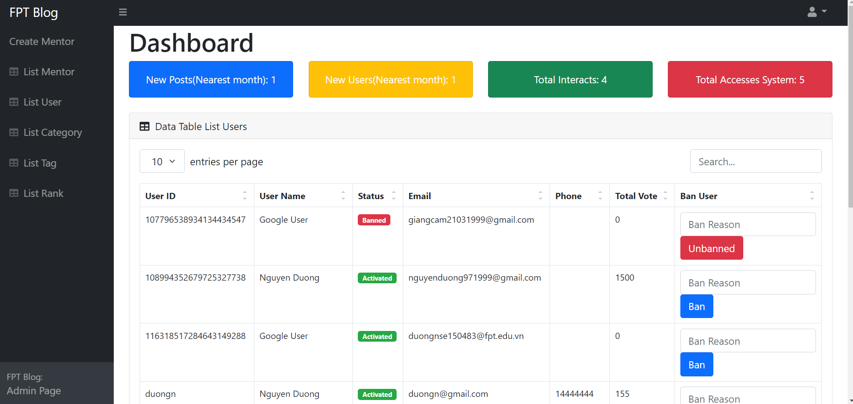

### b.List Mentors

* Function trigger:when the admin presses the "List mentor" function on the navigation bar on the left side of the screen. This function will automatically appear within 2 seconds
* Function description:This function is for the admin to manage mentors list.
* Screen layout: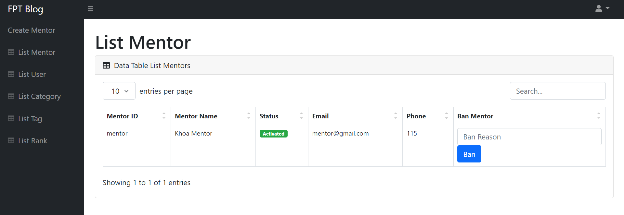
* Function Details: admin can manage mentors list, ban users and unban mentors, in addition.

### c.List Categories

* Function trigger:when the admin presses the "List Category" function on the navigation bar on the left side of the screen. This function will automatically appear within 2 seconds
* Function description:This function is for the admin to manage categories list.
* Screen layout:

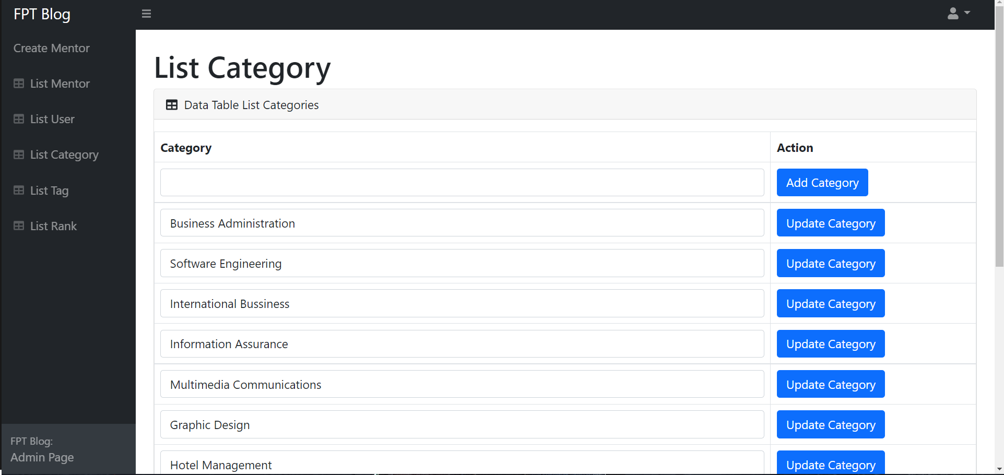

* Function Details: admin can manage categories list, create a new category and edit an existing category.

### d.List Tags

* Function trigger:when the admin presses the "List Tag" function on the navigation bar on the left side of the screen. This function will automatically appear within 2 seconds
* Function description:This function is for admin to view tags list.
* Screen layout:

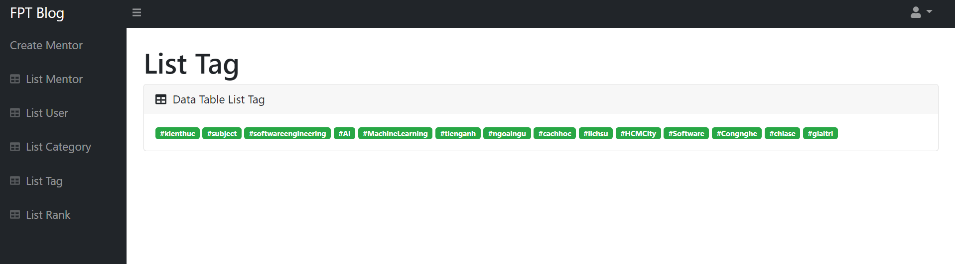

* Function Details: admin can view tags list.

### e.List Ranks

* Function trigger:when the admin presses the "List Rank" function on the navigation bar on the left side of the screen. This function will automatically appear within 2 seconds
* Function description:This function is for admin to view ranks list.
* Screen layout:

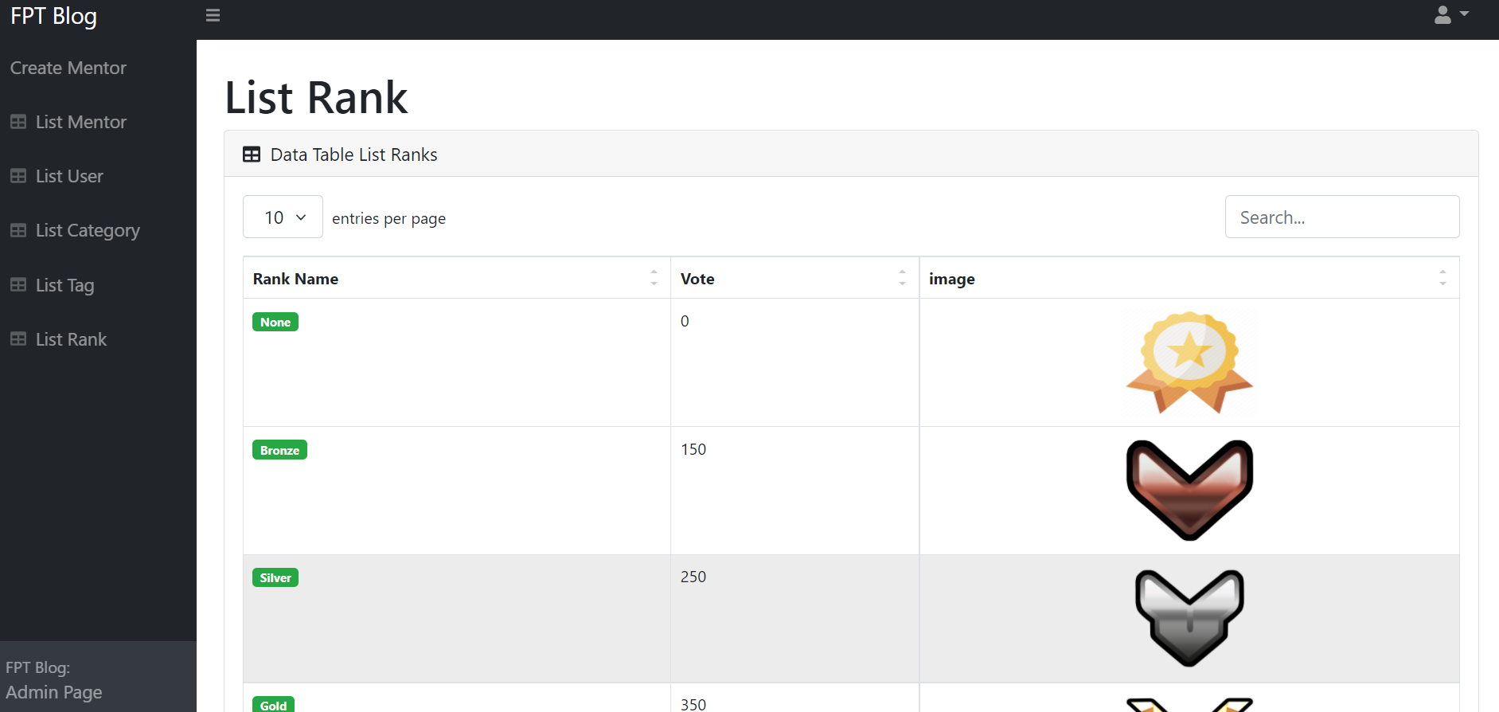

* Function Details: admin can view ranks list.

### f.Create New Mentor

* Function trigger:when the admin presses the "Create Mentor" function on the navigation bar on the left side of the screen. This function will automatically appear within 2 seconds
* Function description:This function is for admin to create a new mentor.
* Screen layout:

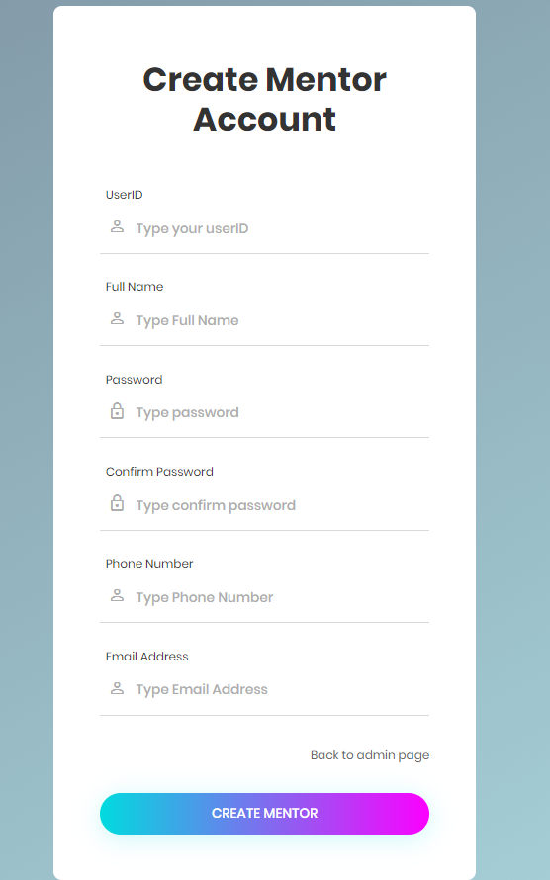

* Function Details: admin can create a new mentor.

## 2. Mentor Management

### a. List Waiting Post

* Function trigger: when mentor login to the system. This function will automatically appear within 2 seconds
* Function description:This function is for a mentor to manage list waiting posts, view Detail and approve or deny this post.
* Screen layout:

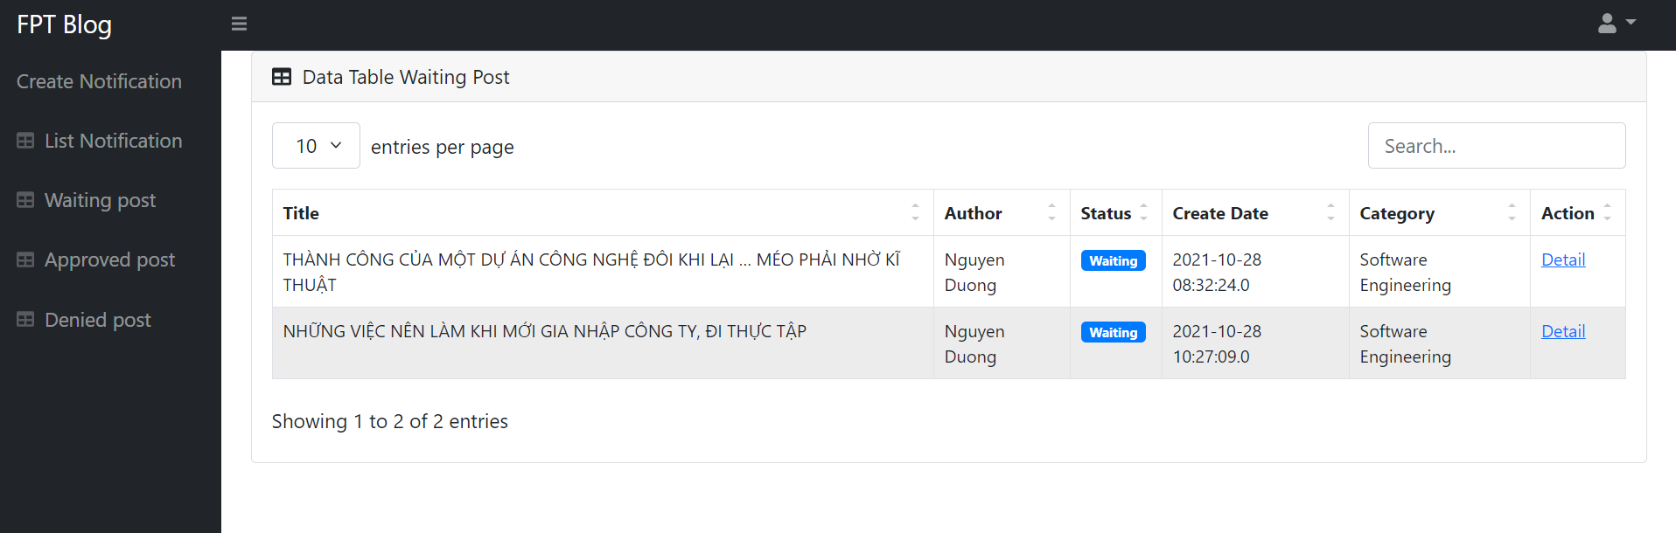

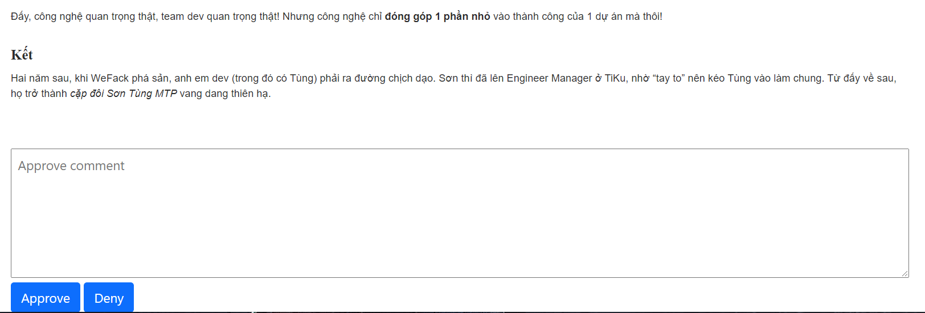

* Function Details: Mentor can see all waiting posts. Mentors can click on the detail link to view the details of the post. Mentors can make comments and approve or deny posts.

### b. List Approved Post

* Function trigger: when the mentor presses the "Approved Post" function on the navigation bar on the left side of the screen. This function will automatically appear within 2 seconds.
* Function description:This function is for a mentor to view list approved posts, view details of this post.
* Screen layout:

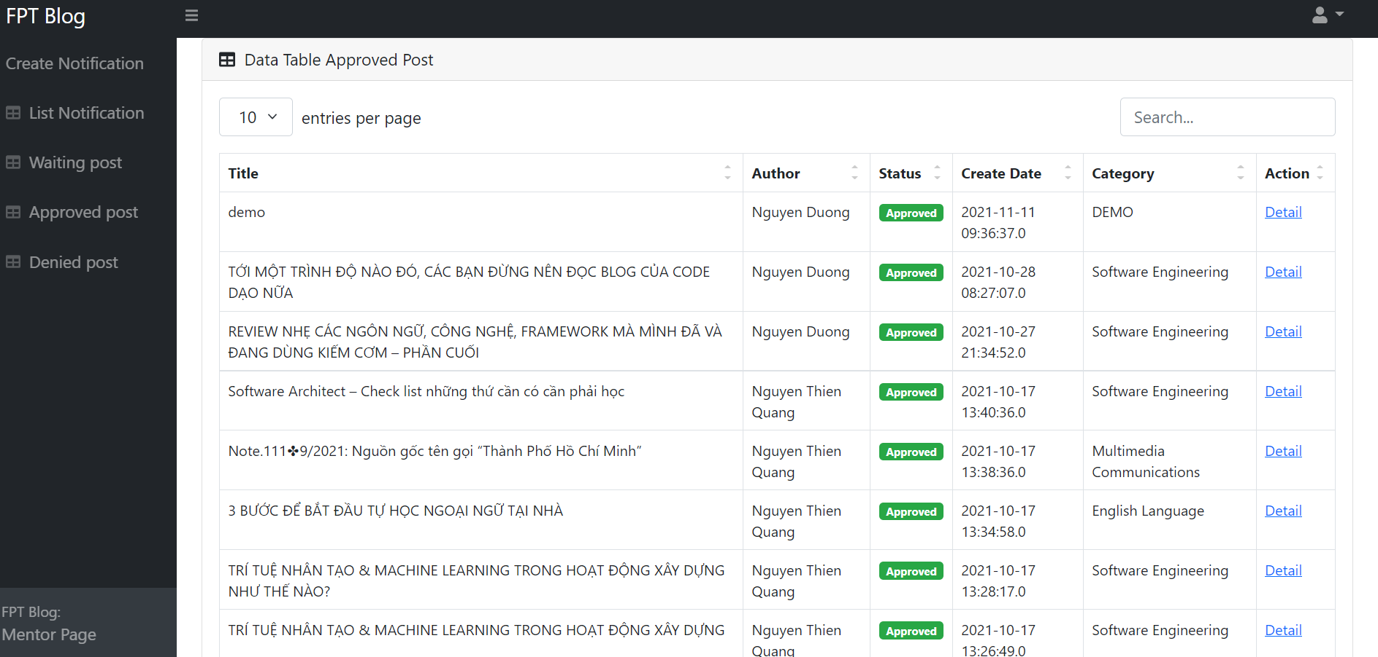

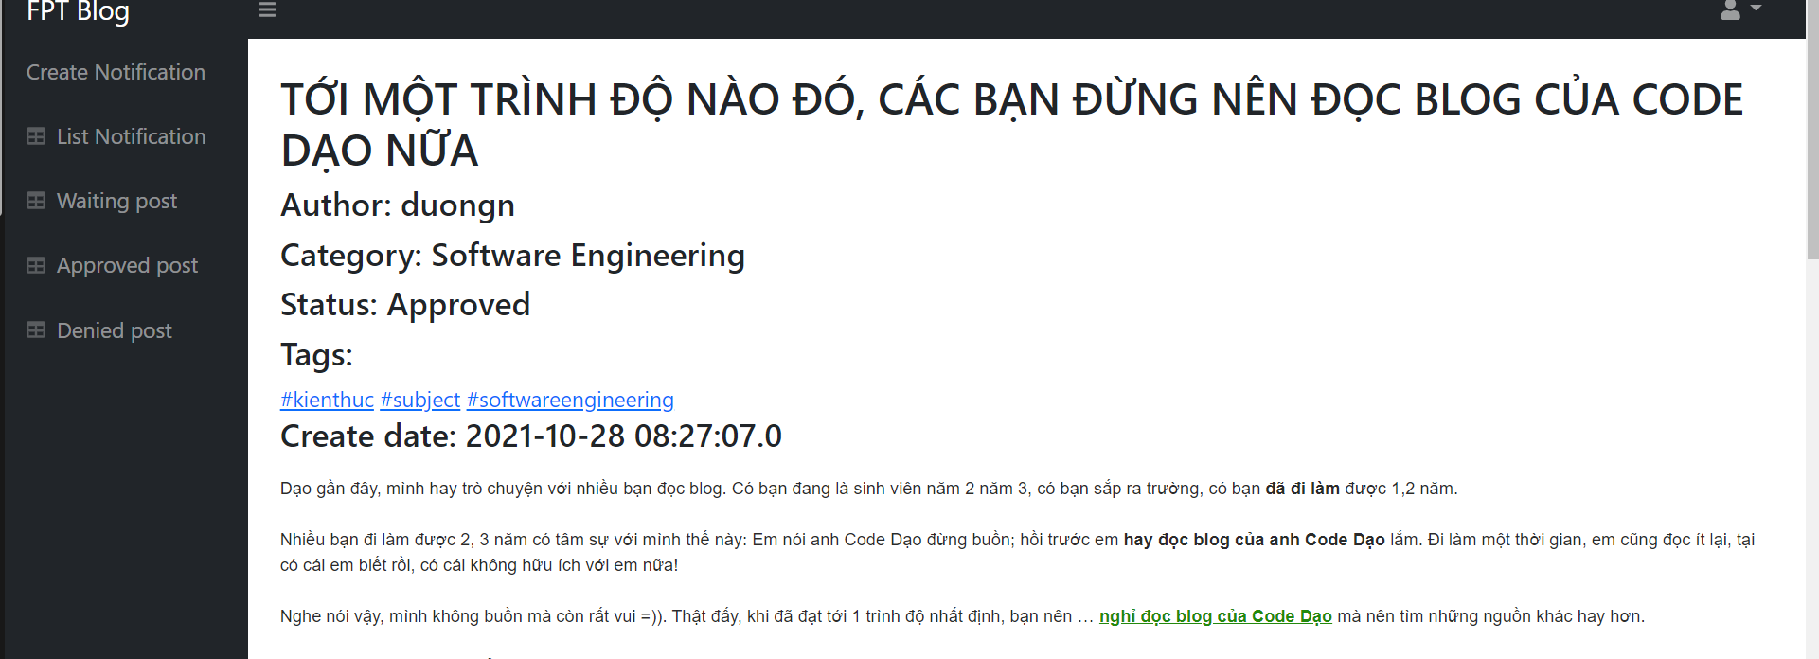

* Function Details: Mentor can see all approved posts. Mentors can click on the detail link to view the details of the post.

### c. List Denied Post

* Function trigger: when the mentor presses the "Denied Post" function on the navigation bar on the left side of the screen. This function will automatically appear within 2 seconds.
* Function description:This function is for a mentor to view list denied posts, view details of this post.
* Screen layout:

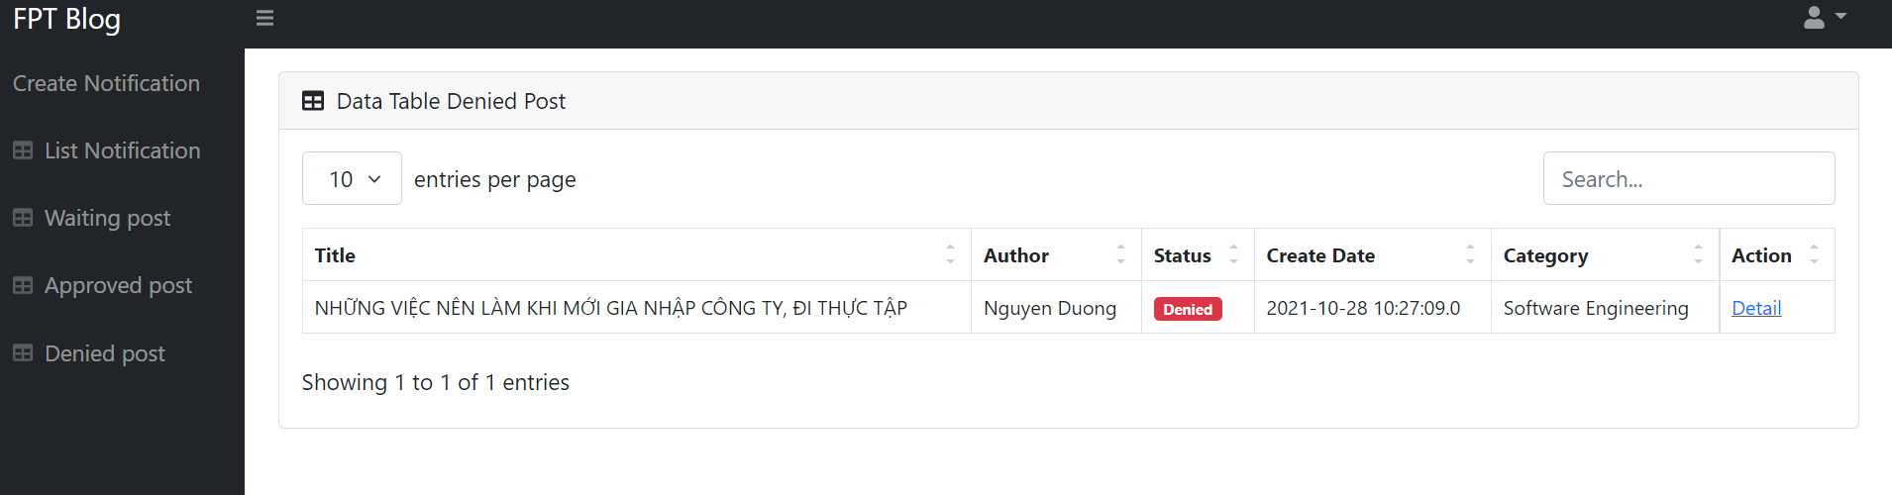

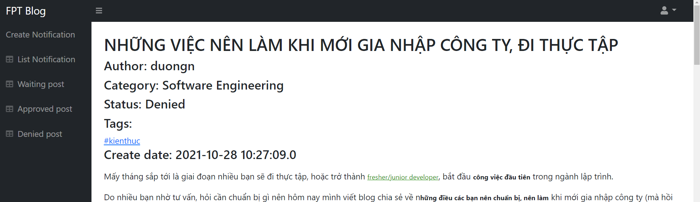

* Function Details: Mentor can see all denied posts. Mentors can click on the detail link to view the details of the post.

### d.Create New Notification

* Function trigger:when the mentor presses the "Create Notification" function on the navigation bar on the left side of the screen. This function will automatically appear within 2 seconds
* Function description:This function is for a mentor to create a new notification.\
* Screen layout:

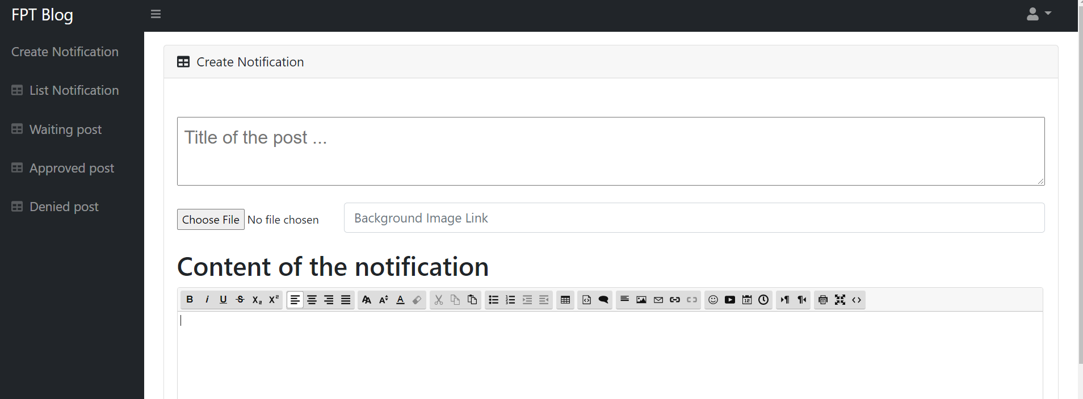

* Function Details: admin can create a new notification, the format of notification is same with normal post..

### e. List Notification

* Function trigger: when the mentor presses the "List Notification" function on the navigation bar on the left side of the screen. This function will automatically appear within 2 seconds.
* Function description:This function is for a mentor to view list notifications, view details of this post.
* Screen layout:

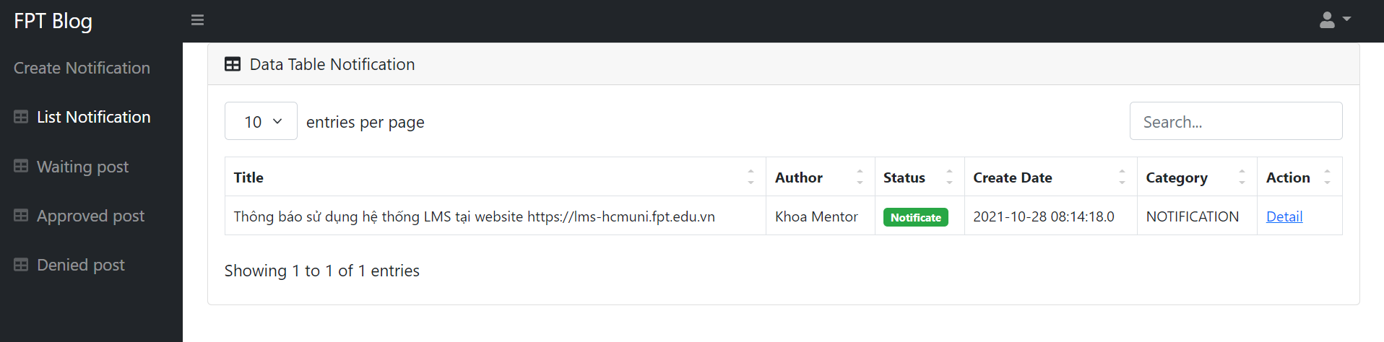

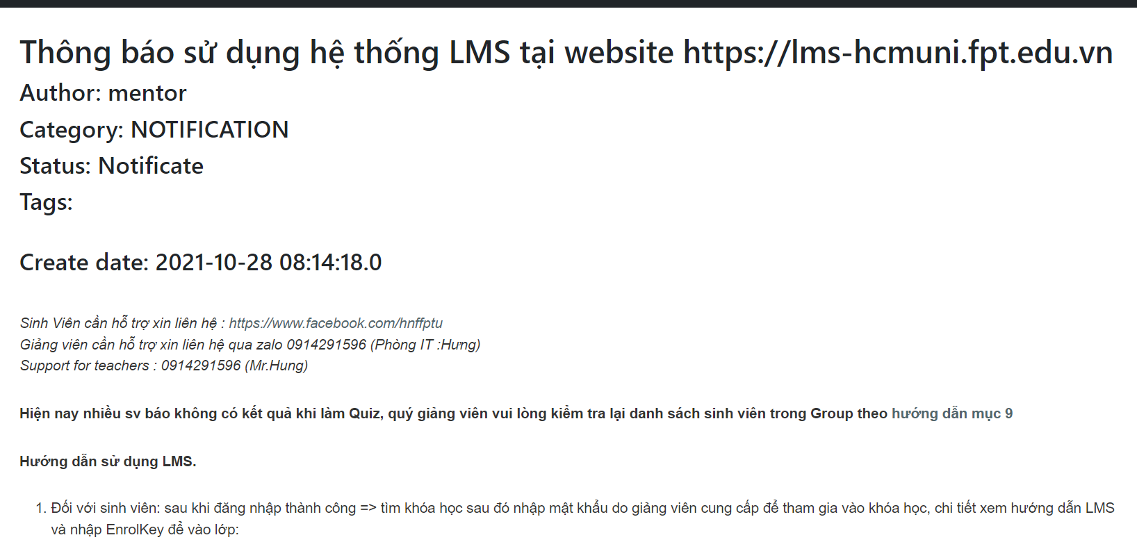

* Function Details: Mentor can see all notifications. Mentors can click on the detail link to view the details of the notification.

## 3. Student.

### a.View Post

* Function trigger:when the user clicks on any post that appears on the home page. Viewpost page will appear on the screen. This function will automatically appear within 2 seconds
* Function description:This function is for a user to view a post.
* Screen layout: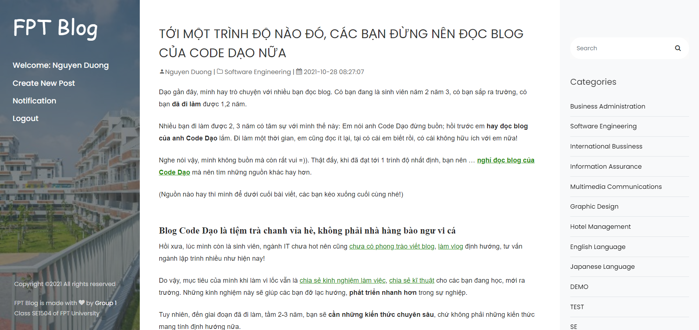

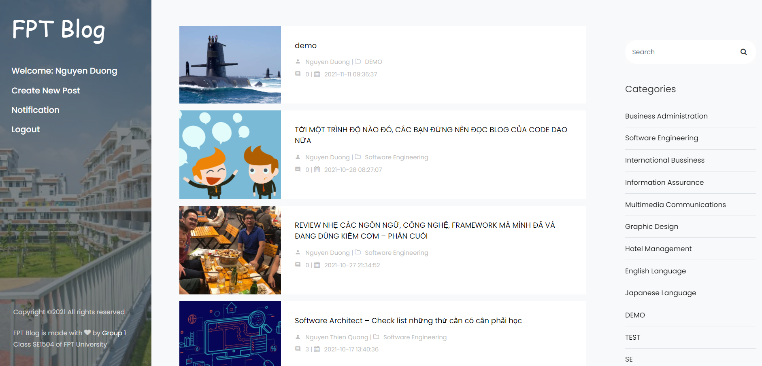

* Function Details:Users can see all details of this post, including:title,content, author, category,date time...

### b.Comment and vote on Post

* Function trigger:when the user clicks on any post that appears on the home page. Viewpost page will appear on the screen. This function will automatically appear within 2 seconds
* Function description:This function is for a user to interact with the post by comment or vote.
* Screen layout: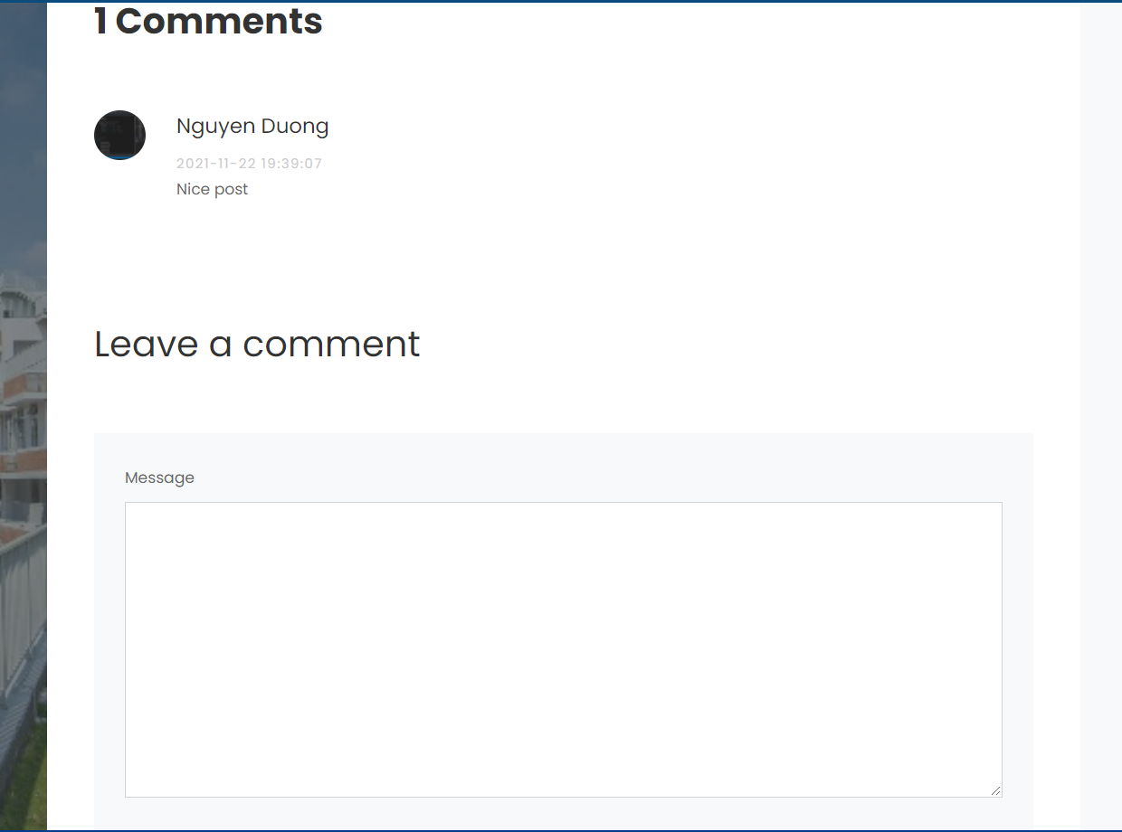
* Function Details:Users can see and give a comment/vote on this post.

### c.View Notification

* Function trigger:Function trigger: when the user presses the "Notification" function on the navigation bar on the left side of the screen. View notification page will appear on the screen. This function will automatically appear within 2 seconds
* Function description:This function is for a user to view notification from mentors.
* Screen layout:

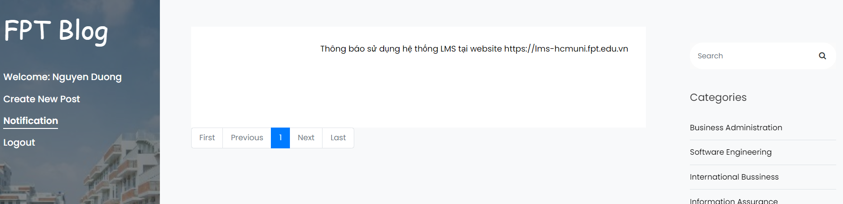

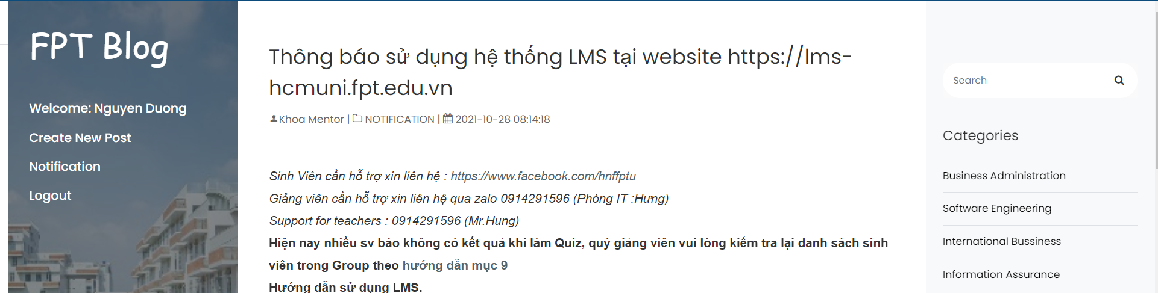

* Function Details:Users can see all details of this notification.

### d.Create New Post

* Function trigger:when the user presses the "Create New Post" function on the navigation bar on the left side of the screen. This function will automatically appear within 2 seconds
* Function description:This function is for a user to create a new post.
* Screen layout:

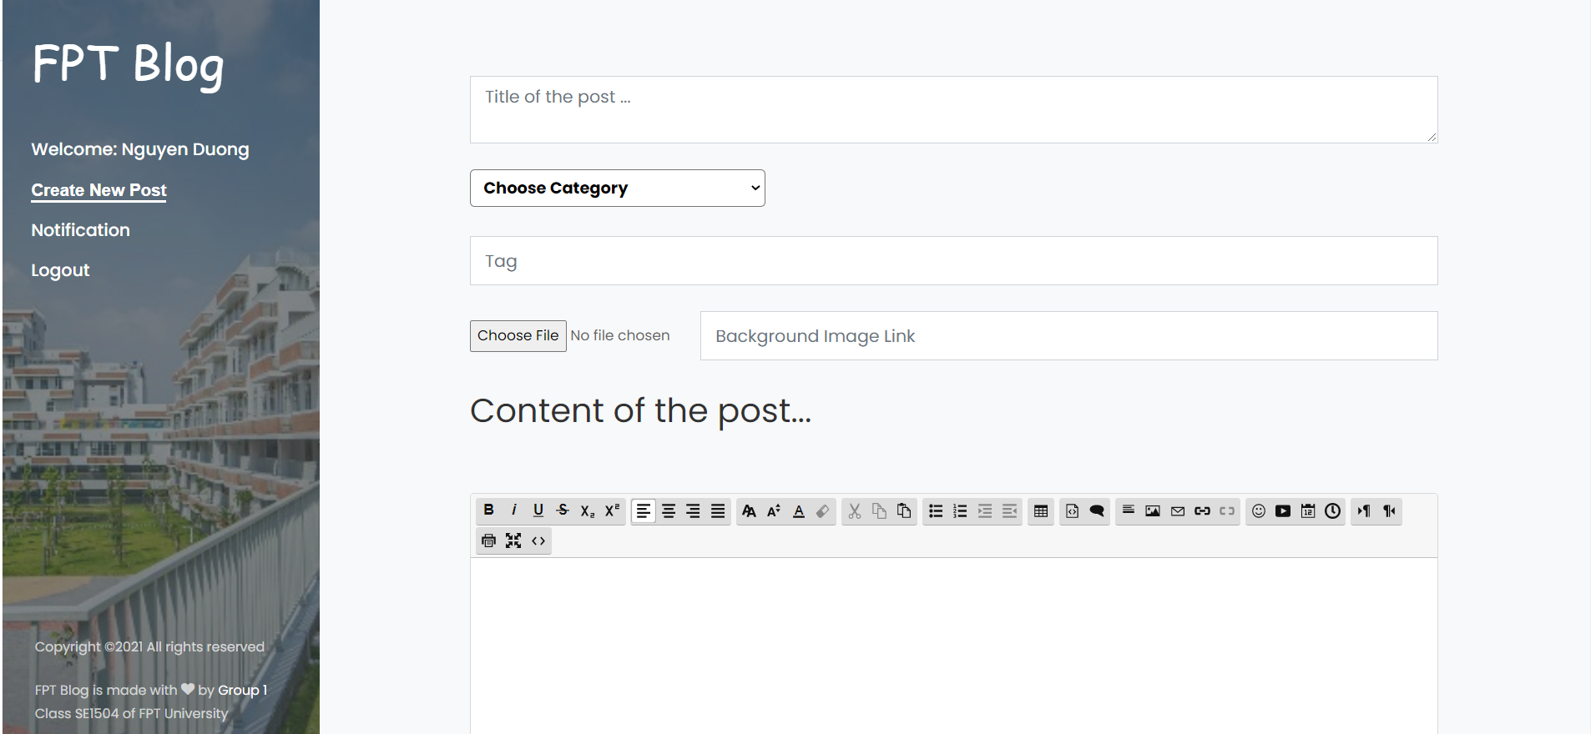

* Function Details: User fills in information of the post like: title, category, tag , background image, content.

### e.Edit Profile

* Function trigger:when the user presses the "Welcome ……………..t" function on the navigation bar on the left side of the screen. This function will automatically appear within 2 seconds
* Function description:This function is for a user to edit their profile.
* Screen layout:

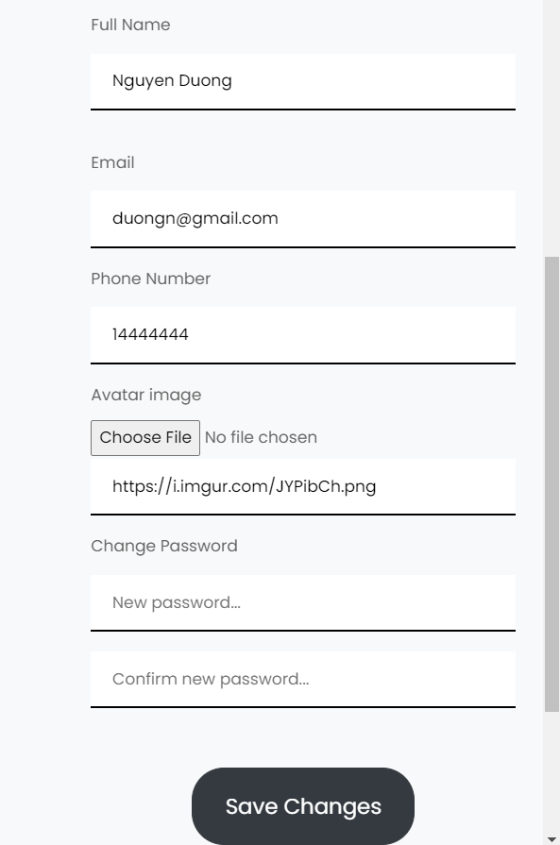

* Function Details: User fills in information like: Fullname, email,phone,avatar, and change password.

## 4. Guest.

### a.Create New Account

* Function trigger:when the guest presses the "Sign Up" function on the navigation bar on the left side of the screen. This function will automatically appear within 2 seconds
* Function description:This function is for a guest to create a new account.
* Screen layout:

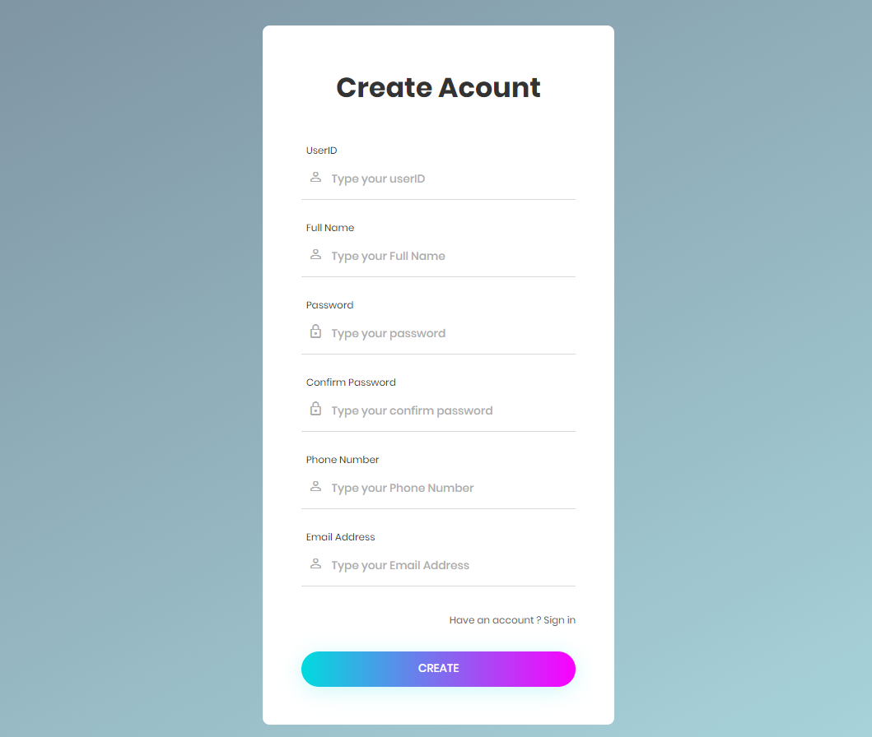

* Function Details: Guest fills in information such as userID, password, Full Name, Phone, and Email to create a new account.

### b.View Post

* Function trigger:when the guest clicks on any post that appears on the home page. Viewpost page will appear on the screen. This function will automatically appear within 2 seconds
* Function description:This function is for a guest to view a post.
* Screen layout:
* Function Details:Users can see all details of this post, including:title,content, author, category,date time...But they can’t comment on this post